Sprint 4

Topic: Environment Design Style

References:

* Area based on real life regatta
* Volcanic/Hot Springs area/Gaisers
* Cave systems
* Spring Time

Pinterest Board: https://pin.it/7qP6eaP

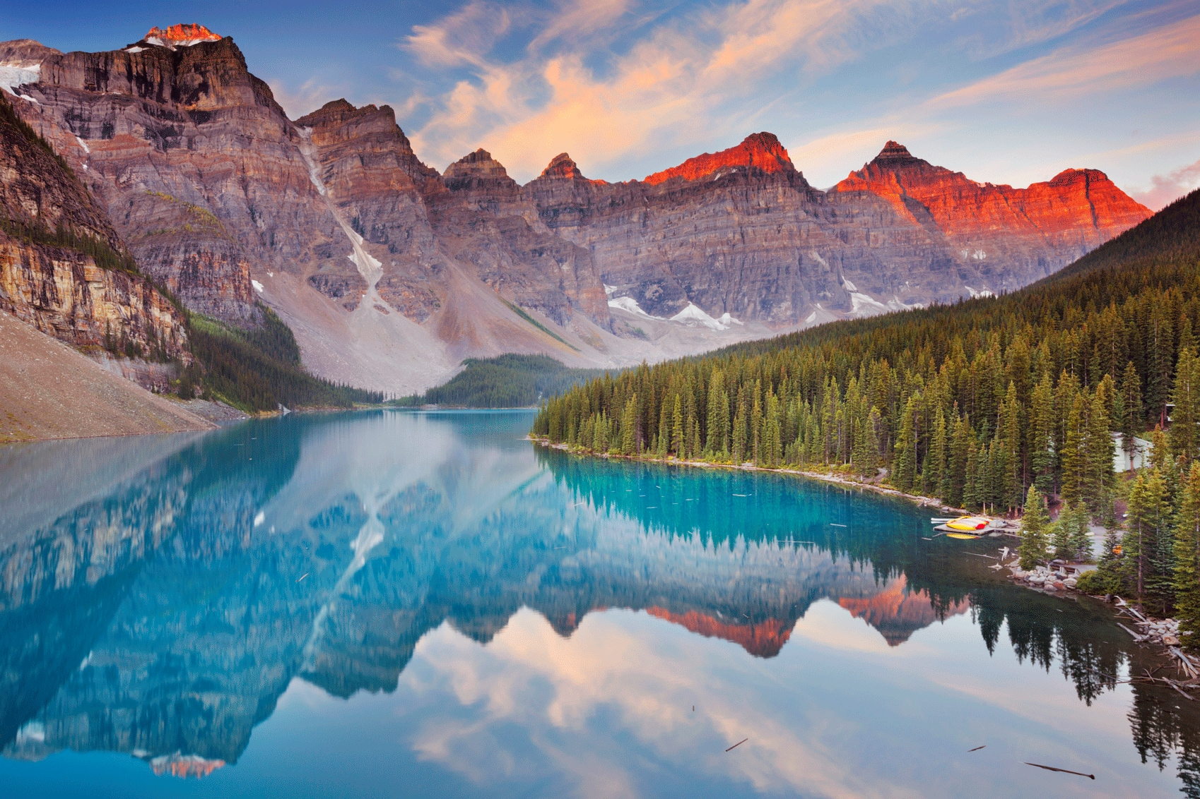

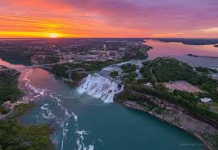

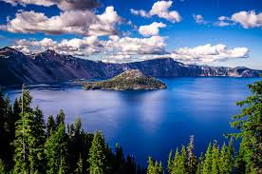

Time of Day:

Mid-Sun as not to be too dark for an environment that isn’t supposed to have artificial light, nor too bright to annoy players.

Time of Year:

Spring Time as to maximize range of colour.

Features:

* High Cliffs
* Some Scenic Waterfalls
* Low Area to Top Left
* Some Cave Systems
* Stacks